DBMS Laboratory
Day 1:
Date: 29 Jan 2021

Installation:
In Ubuntu 20.04 LTS

To install it, update the package index on your server if you’ve not done so recently:
Command : sudo apt update

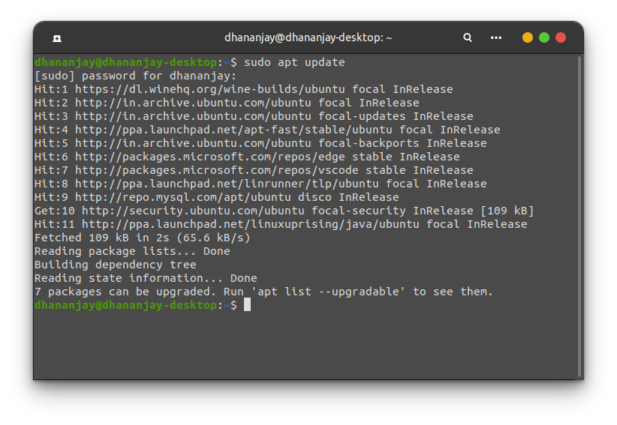
Then install the mysql-server package:
Command : sudo apt install mysql-server
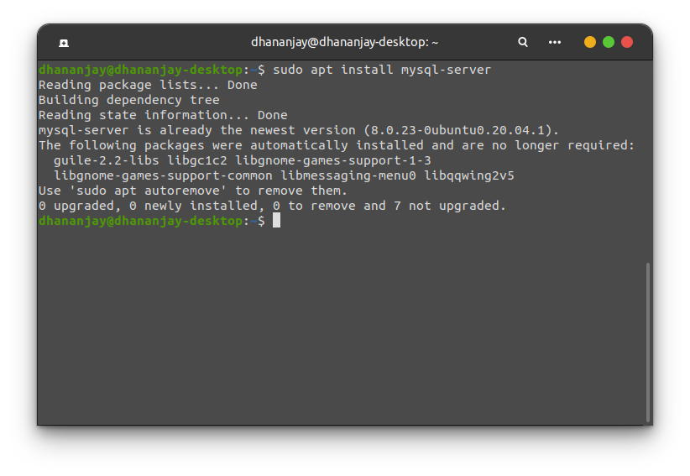

For fresh installations of MySQL, you’ll want to run the DBMS’s included security script. This script changes some of the less secure default options for things like remote root logins and sample users.

Run the security script with sudo :

Command : sudo mysql_secure_installation

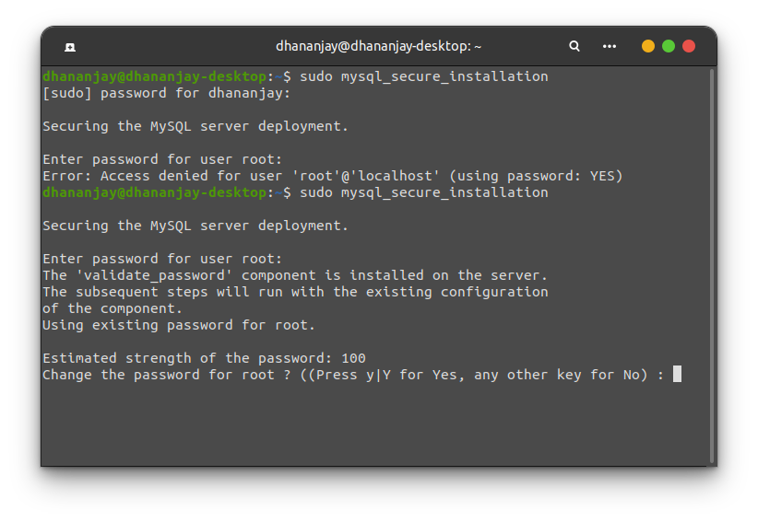
Run the security script with sudo :

Command : sudo mysql -u root -p
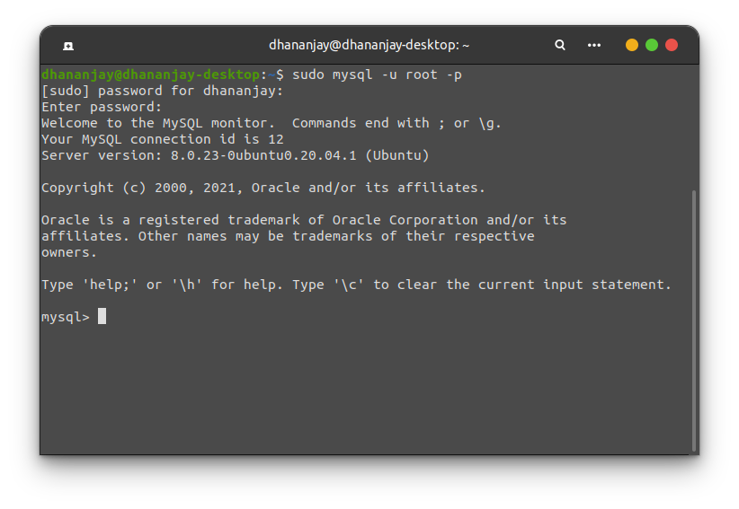

Then install the mysql-workbench package:
Command : sudo apt install mysql-workbench-community

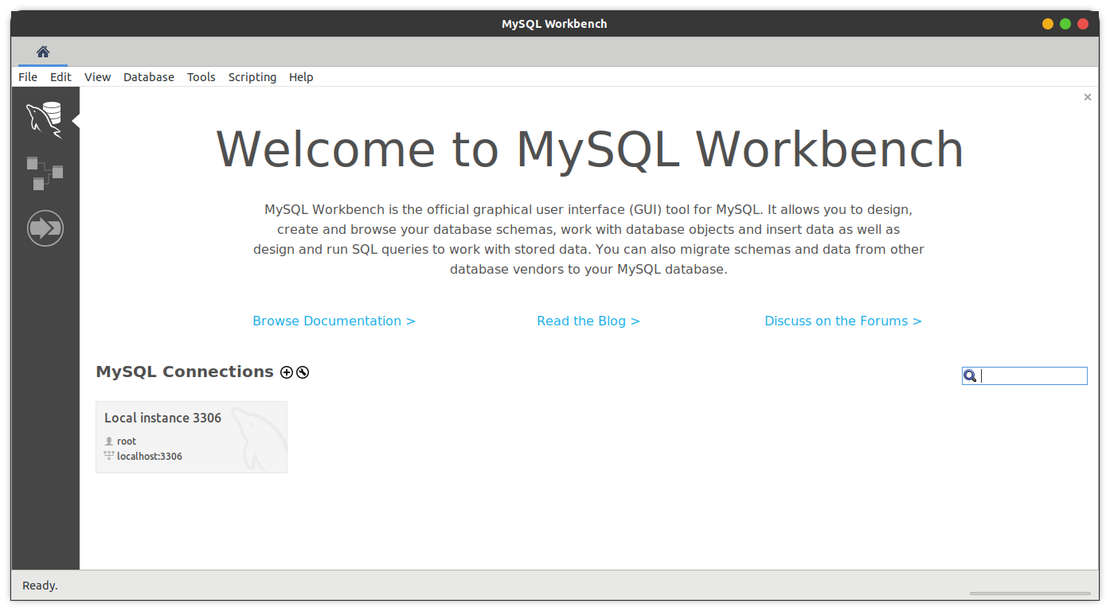
Then, Using MYSQL
Command : sudo mysql

Commands Used:
SHOW DATABASES;

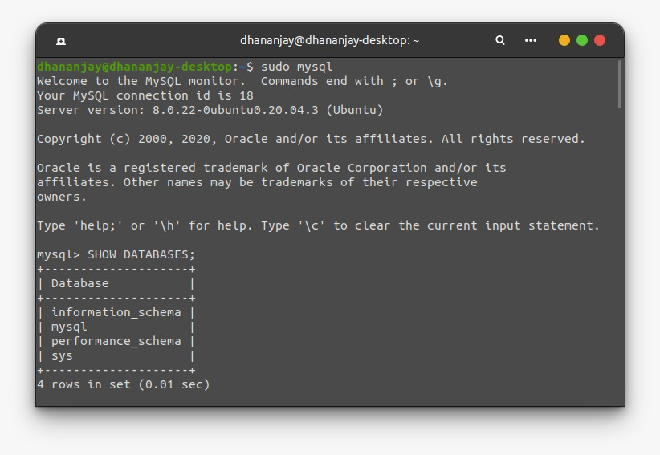

USE DBNAME*;
SHOW TABLES;

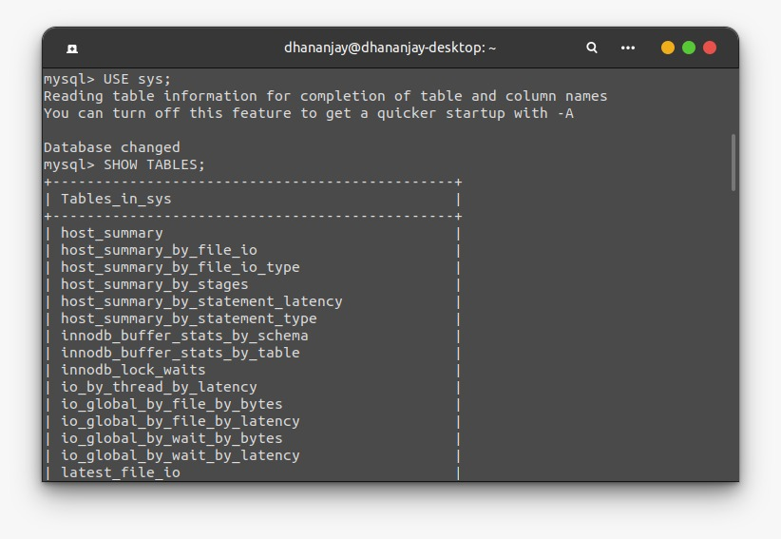
SHOW COLUMNS FORM LIST*;

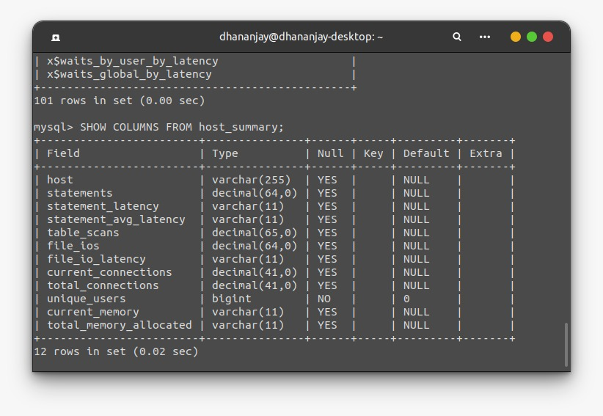
CREATE DATABASE DBNAME*;

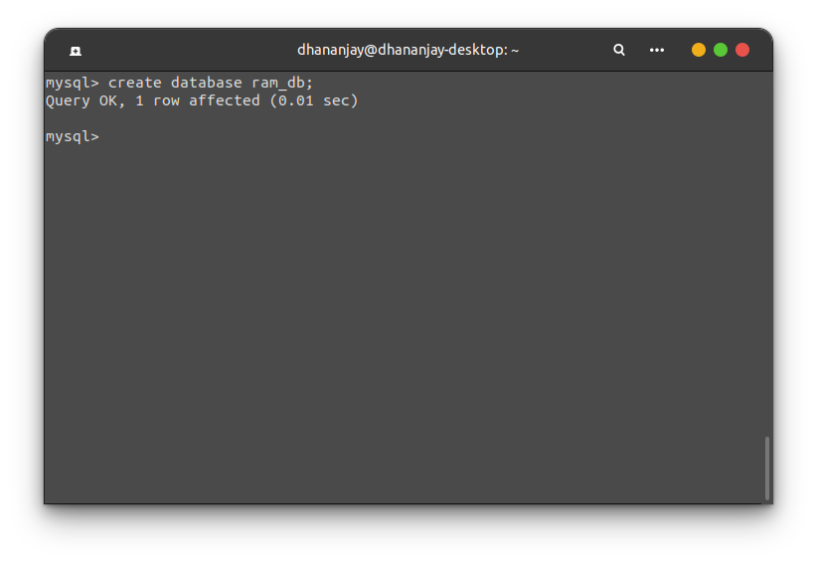
Day 1:
Date: 5 Feb 2021

Commands Used:

CREATE DATABASE TESTING;
USE TESTING;
CREATE TABLE SHOP1 (
article INT (4) ,
dealer CHAR (20) NOT NULL,
price DOUBLE (16, 2 ) NOT NULL,

PRIMARY KEY (article));

INSERT INTO SHOP1 VALUES
(1, 'A', 3.45), (2, 'B', 3.99), (3, 'A',10.99), (4, 'B',1.45), (5, 'C',1.69),(6, 'D',1.25), (7,'D',19.95);
SELECT * FROM shop1;

